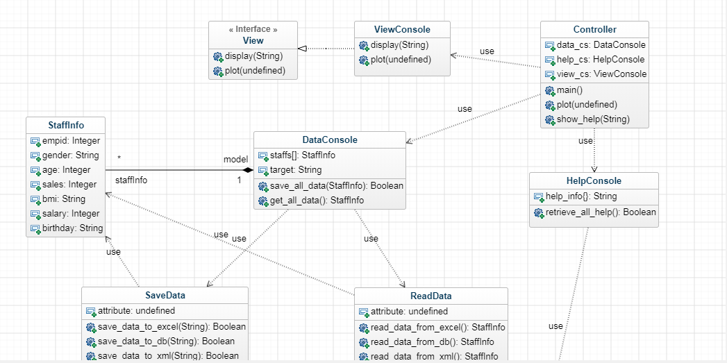

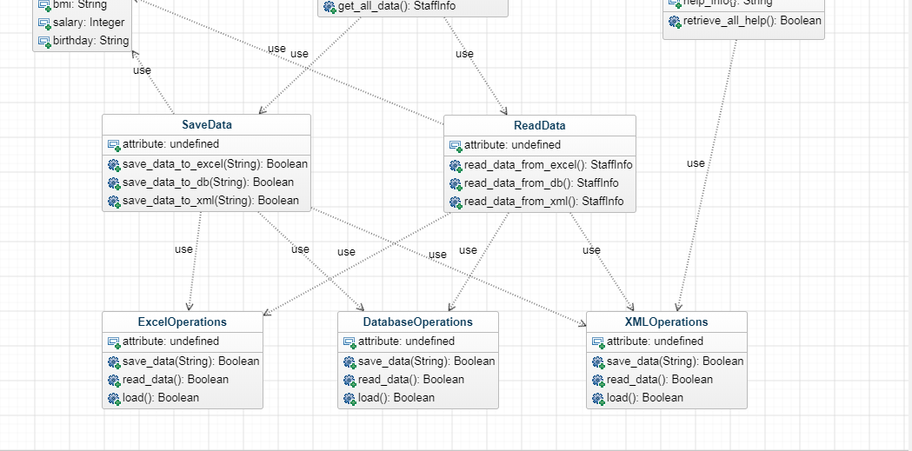

I don’t have any class diagram tools. So the blocks above stand for classes are estimated to be built for the program.

We need to code the model, controller, ViewConsole and probably an interface for the ViewConsole. Then we will have rules to code in common.

Is there any Github repository available for the assignment at the moment? My github is [heyerique@gmail.com](mailto:heyerique@gmail.com)Hey it’s michael. Really like your diagram, looks like you put a fair bit of work into it. May need to add methods etc to it but I’m happy to push ahead with that and look into coding. Think you need to link your actual profile page for us to get your github? Happy to use yours though, publics probably best? Long as we can add to it then that sounds sweet. I take it you imply above that the view console includes both the data and help console views?

Eric

I don’t have clue about methods actually needed for each class. I think we can figure out when coding. The view console is used for displaying only, the help console uses it for output. But not sure if it’s ok :P happy to hear any ideas from you guys.

My github profile is: <https://github.com/heyerique>

Hi guys, I am sorry; I have been Cought up by unexpected issues. Even though; i sent email to you guys earlier on Sunday morning. Have you received it?

By the way; the class diagram look pretty awesome. One suggestion is:

Do we need to have three different view of the “plottly” I mean chart i.e Pie, Bar and so on. Can we add that into different class or same class with different method?

2. Doc testing and unit testing as well?

Can I choose to do coding on “database Operations” on MySQL? Thanks

And also as discussed; Help Command Document too.

Thanks

Eric

I’ve updated the diagram a little bit. As Vaishali mentioned, the plotting method will be defined in the view console only.

The controller class has one method runs an endless loop for processing user input and displaying.

View console is used for displaying text output and plotting

Help console access help text from a local file or database, initiate and retrieve a specific help instruction by a keyword.

Data console is for saving and retrieving data.

Not sure if we need a seperate class or a function for processing instruction keywords inputted by user, like HELP \*\*\*, ADD \*\*\* etc..

Need suggestions for names of classes, functions, variables…

The diagram used xml, excel and database for reading and saving data as examples, you can choose another one you want.

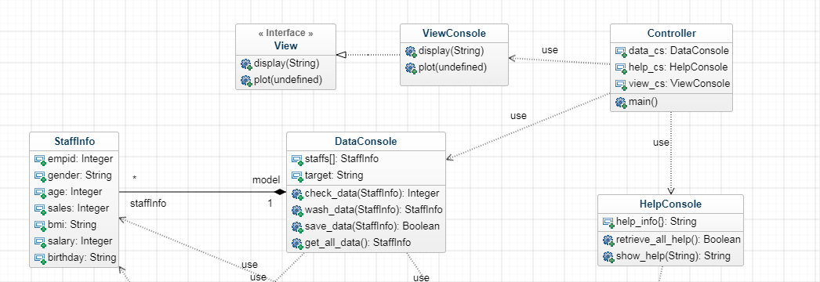

I will do CSV  
  
I’d prefer to do from a text file as opposed to Excel I think. Also Matploblib looks pretty straight forward from what I’ve looked at.

Eric

I am doing CSV, and updated the diagram a little bit

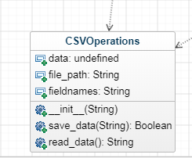

I will have look at MVC, hopefully i will be able to build its frame.

B584, M, 26, 565, Underweight, 756, 02-01-1992

C784, F, 19, 785, Normal, 456, 06-05-1998

C3P0, M, 18, 453, Overweight, 586, 20-12-1990

H200, F, 32, 574, Obese, 678, 02-03-1986

D981, F, 56, 656, Normal, 898, 31-12-1963

T345, M, 78, , 434, Overweight, 987, 05-01-1940

B983, F, 45, , 654, Underweight, 765, 06-08-1972

J753, M, 26, 345, Normal, 434, 29-02-1992

J531, F, 30, 576, Overweight, 654, 30-2-1988

Z568, F, 67, 753, Normal, 879, 03-12-1993

The broken data looks great, but i suggest use two digits for date and month. Like B584, M, 26, 565, Underweight, 756, 02-01-1992 - WIll leave one with a single digit with the assumption of user error. Left errors in a lot of the data - means we account for each error. 30-2-1998, non matching birthdays and ages, emp Ids that are incorrect.

We will do data validation to ensure the data input by user is validate, also do data wash to format data to the one in database or local file. I assume that the date and month format of MySQL is two digits.

I made up some broken data we could use as well

Eric

I’ve created the View interface, the view console, the staff info class.

Here’s the git link, you should be able to check it out:

<https://github.com/heyerique/Python-Assignment1.git>

I’ve added methods to the view console, and updated the class diagram.

